Rama Hassabelnabi
POE - Westwood High School
4/26/16

3.3.1 Marble Sorter
Team Members: Jugal Amodwala, Michael Diaz, Michael Friedmann

Design Problem

Problem: The National Recreation Park Association, in an effort to solve a problem in their park, has placed dumpsters for recyclable items. They need a machine for their sorting facility that will sort the recyclable materials.

Design Statement: Our team will design, build, and test that sort recyclable items.

Constraints: The machine that we are to build will sort four different ½ in. material spheres totaling sixteen marbles. There will be extra credit for sorting five different material spheres totaling twenty marbles. Examples of the materials are steel, aluminum, wood, opaque plastic, and clear plastic. It must be built using only the VEX kit, and materials approved by the teacher. The machine has to successfully separate the marbles into individual holding bins. The separation process must be fully automated, and efficient.

Brainstorming Idea
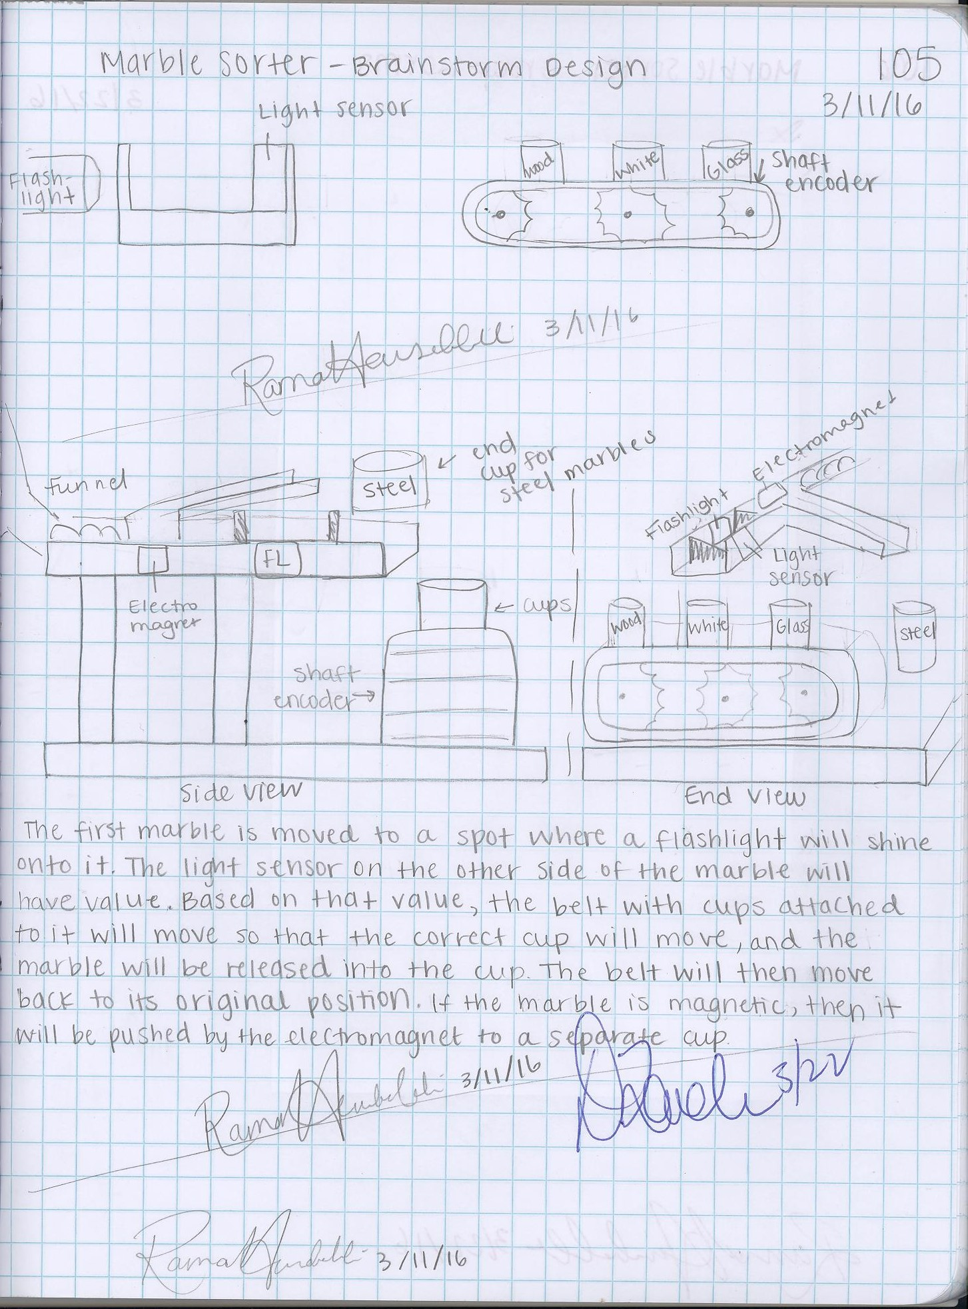
Description
The twenty marbles will be loaded into a funnel at the beginning of the machine. The marbles will roll out, and if the marble is magnetic, it will be pushed by the electromagnet onto a different path into its own cup.
The other marbles will move one by one to the spot where a flashlight will shine onto it. The light sensor on the other side will measure a value that shows the translucence of the marble.
Based on that value, the belt with cups attached to it will move so that the correct cup will move, and the marble will be released into the cup. That belt will then move back to its original position.

Decision Process

Name | Simplicity | Usability | Aesthetics | Feasibility | Build Time | Total
Michael F | 1,1,1,1 | 2,2,2,2 | 5,5,5,4 | 2,2,2,2 | 1,1,2,1 | 44
Jugal | 1,1,1,1 | 2,2,2,2 | 4,4,4,4 | 2,2,2,2 | 1,1,1,1 | 40
Michael D | 3,3,3,2 | 3,3,3,3 | 5,4,4,4 | 4,4,4,4 | 2,2,2,1 | 63
Rama | 5,5,5,5 | 5,5,5,5 | 4,4,4,4 | 4,4,4,4 | 3,3,3,3 | 84

First, each person in our group showed their design and explained how it was going to work. To evaluate each design, our group made a decision matrix and selected simplicity, usability, aesthetics, feasibility, and build time as the criteria. Simplicity is how simple the design is, usability is how easy the machine is to use, aesthetics is how pleasing it is to the eye, feasibility is how easy the machine will be built, and build time is how long we think the design is going to take to construct.
We wanted the design that we were going to build to be not too complex, easy to use, pleasing to the eye, easiest to build, and will take the shortest time to be built. Therefore, we rated each design on a scale from one to five, with one being the lowest rating, and five being the highest rating, meaning it fit into what we wanted from the criteria. Then we added all of the points each design got, and picked the one with the highest to build, so my design was picked.

Final Design Solution
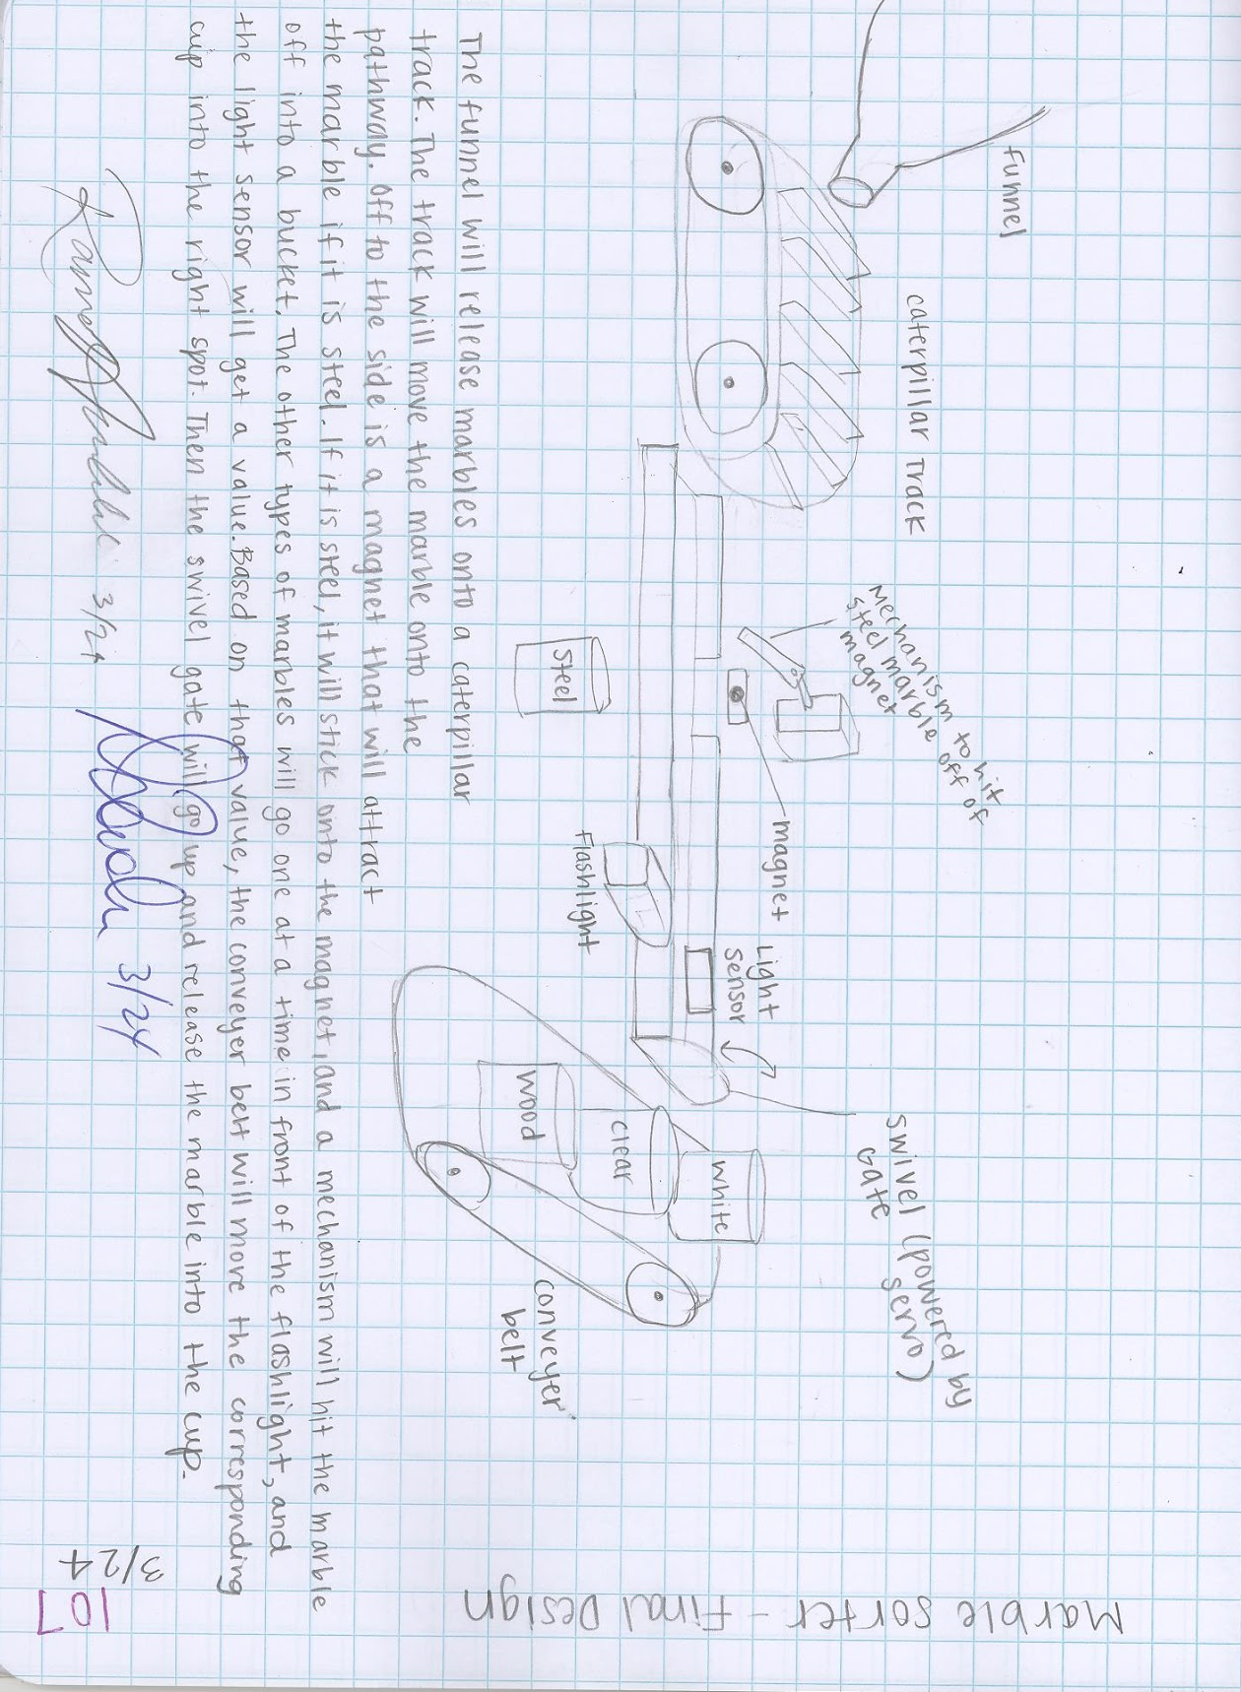

Description
The funnel will release marbles onto a caterpillar track. The track will move the marble onto the pathway. Off to the side is a magnet that will attract the marble if it is steel. If it is steel, it will stick onto the magnet, and a mechanism will hit the marble off into a bucket.
The other types of marbles will go one at a time in front of the flashlight, and the light sensor will get a value. Based on that value, the conveyer belt will move the corresponding cup into the right spot. Then the swivel gate will go up and release the marble into the cup.

Rationale
The design we chose was chosen because it seemed the most practical, and could be built within our time constraint.

Design Modifications

The funnel that released the marbles into the caterpillar track was releasing multiple marbles at once, and none of them were going onto the caterpillar track. To fix this, we added a gate attached to a servo motor that was programmed to open and close every few seconds, and this allowed for one marble to be released at a time onto the caterpillar track.

We used a line follower to differentiate between the clear, white, and wood marbles, but we found that the values the line follower was getting were very inconsistent. We thought this might be because of the differences in the amount of light in the class each day, so we decided to enclose the line follower and flashlight using cardstock and tape.

We experienced some difficulty when trying to figure out how sort the steel marbles. In the design, we were going to have a magnet off the side of the track that would attract the steel marbles into a cup below the track. However, this did not work, so we added a magnet onto the end of a rod,and attached the rod onto a motor that would let it spin and pick rolling steel marbles, and place them into a cup that was placed above.

The cup that was supposed to hold the sorted steel marbles was too high and we could not lower it because then it would interfere with the caterpillar. Therefore, we stuck a plastic tube under a cup so that when the rod with the magnet attached to it would pick up a marble, it would go into the tube, and land in a cup below.

The marbles that were not steel were going to be stopped by a gate at a spot where a flashlight would shine on it, and a line follower would get a value. However, the marble did not stop directly above the line follower, so we added a screw to the gate in order to stop the marble when it was directly above the line follower.

Final Design

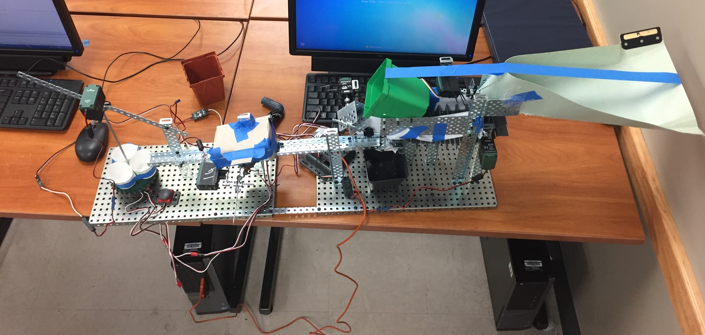

This machine sorted 1 marble correctly, and 3 marbles made it through the entire process.

ROBOTC Program
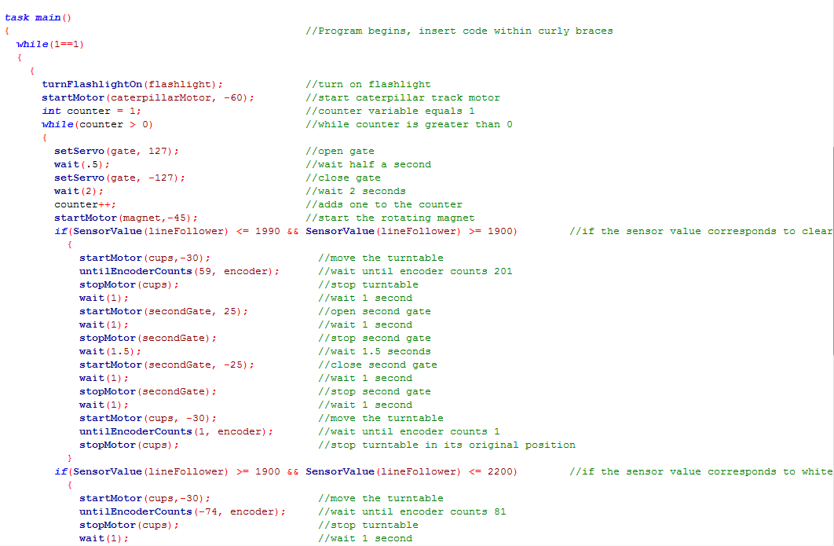
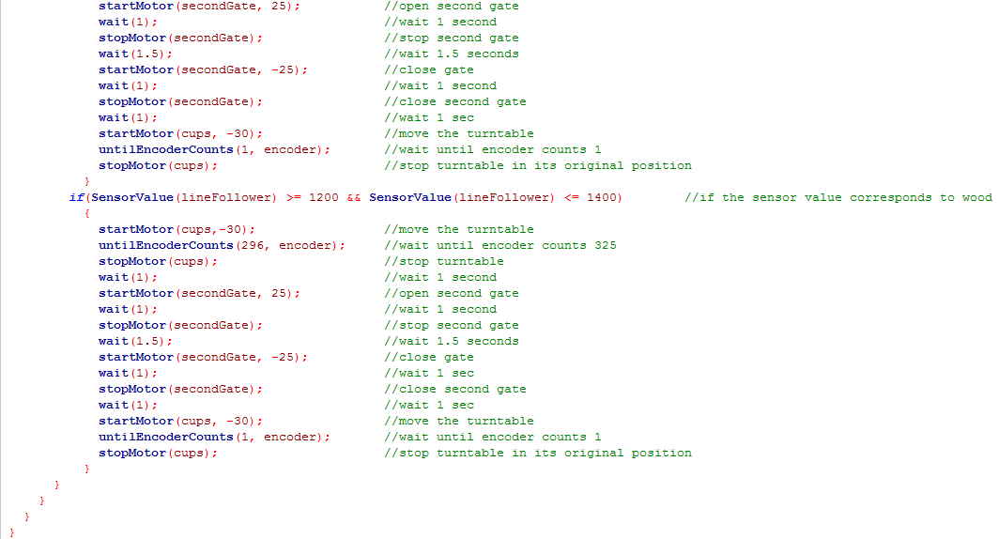

Design Process

Define the Problem
The problem was defined, and constraints were given in the design brief.

Generate Concepts
Each team member made a brainstorm idea and shared how it was going to work. Then to choose a design to build, we made a decision matrix and rated the simplicity, usability, aesthetics, feasibility, and build time of each design.

Develop a Solution
We each drew a detailed final solution drawing that included labels and a written description.

Construct and Test a Prototype
We built the design, and only the funnel, swivel gate, and caterpillar track worked correctly.

Evaluate the Solution
We made many modifications to the design including using a line follower instead of light sensor, covering the flashlight and line follower with cardstock, and replacing the conveyer belt with a turn table.

Present the Solution
We presented our project to the class in an informal presentation.

Team Evaluation

Michael Diaz: Michael was one of the builders. He worked really hard, and had very good ideas about how to resolve the issues that we were having with the machine. He stayed after school and came early to work on the machine. He followed group norms by texting in the group chat when he knew he would be absent or late.

Michael Friedmann: Michael was one of the builders. He came in early to work on the machine, and also had good ideas about how to modify the design. He did his share, followed group norms, and even provided comic relief.

Jugal Amodwala: Jugal was one of the builders. He followed group norms, worked hard, and came in early to work on the machine. He came up with the idea to have a rotating rod with a magnet attached to it to sort the steel marbles, and other ideas about how to fix some of the problems we were having with the design.

Rama: I was the programmer, so I wrote and modified the program, and I did not contribute to the construction of the machine. I think I did a good job because I followed group norms, came in early, and listened to everyone’s ideas.

Reflection

- What would your team do differently with your design solution and why?
The caterpillar track was inefficient, and had trouble rotating because of its size, so I would replace it with a ramp that had a swivel gate at the end. This way all the marbles are already lined up, and the swivel gate would ensure that one marble would be released at a time. Also, I would remake the turntable by using cardboard making it bigger because the our turntable was too small and did not work correctly.

- What was the most challenging aspect of this design problem?
The most challenging aspect of this design problem was the constraint that said the marbles must be separated into individual holding bins because we had trouble getting the turntable to turn to the correct cup.

- What did you learn?
I learned to listen to everyone’s ideas, no matter how unrealistic because they can always be modified into something feasible. I also learned to not be afraid to make drastic design modifications because they are usually for the better.

- What were some of the challenges of working in a design team?
Working in a design team made it harder decide on things because there were different people with different ideas about how they wanted the design to come out. Also, it was harder to find a time to work on the machine before or after school because each person in the group is busy and has different schedules.

