Design Modifications

The axle on the sprocket system that contained a wheel and axle was not parallel to the base because of the weight of the wheel, and therefore was not sturdy. To fix this, we made it so that the axle would be attached to a support to keep it straight and secure. It worked very well and kept the axle from moving around.
On our original design, we had a crank driving the sprocket system. However, we were unable to tightly secure the crank to the axle, so we used a wheel to drive the sprocket system instead. The wheel drove the sprocket system very well because of its large diameter.
The weight that we are using was too wide to be pulled up the inclined plane. To fix this, we doubled the width of the inclined plane, and added a railing to one side. By doing this, the weight was able to go up the inclined plane without falling off the side.
The fixed pulley was supposed to be held up by two towers. Because of space and sturdiness issues, we attached the pulley to one tower. This saved space and worked well with the other components.
To increase the size of the compound machine, we attached two bases together with screws. When we attached the pulley to the base, it added weight to one side, and caused the bases to move around. We then moved the pulley so that it was screwed onto both bases to keep them together.

Final Design Presentation

In our official test, our compound machine worked very well. All mechanisms worked correctly individually and together. The criteria of lifting the object a vertical distance of 6 inches in under 3 minutes, was met.
- IMA
  - Inclined Plane: De = 12.5 in / Dr = 6 in → 2.08
  - Fixed Pulley: 1
  - Sprocket System: Dout = 24/ Din = 18 → 1.33
  - Wheel & Axle: De = 4.1 in/ Dr = 2.43 in → 1.69
De = 3.19 in/ Dr = 0.13 in → 24.54
- AMA
  - Fr = 244g/ Fe = 60g → 4.07
- Efficiency
  - (AMA = 4.07/IMA = 114.73) * 100 → 3.55%
- Run Time
  - Under 3 minutes

Final Design Pictures
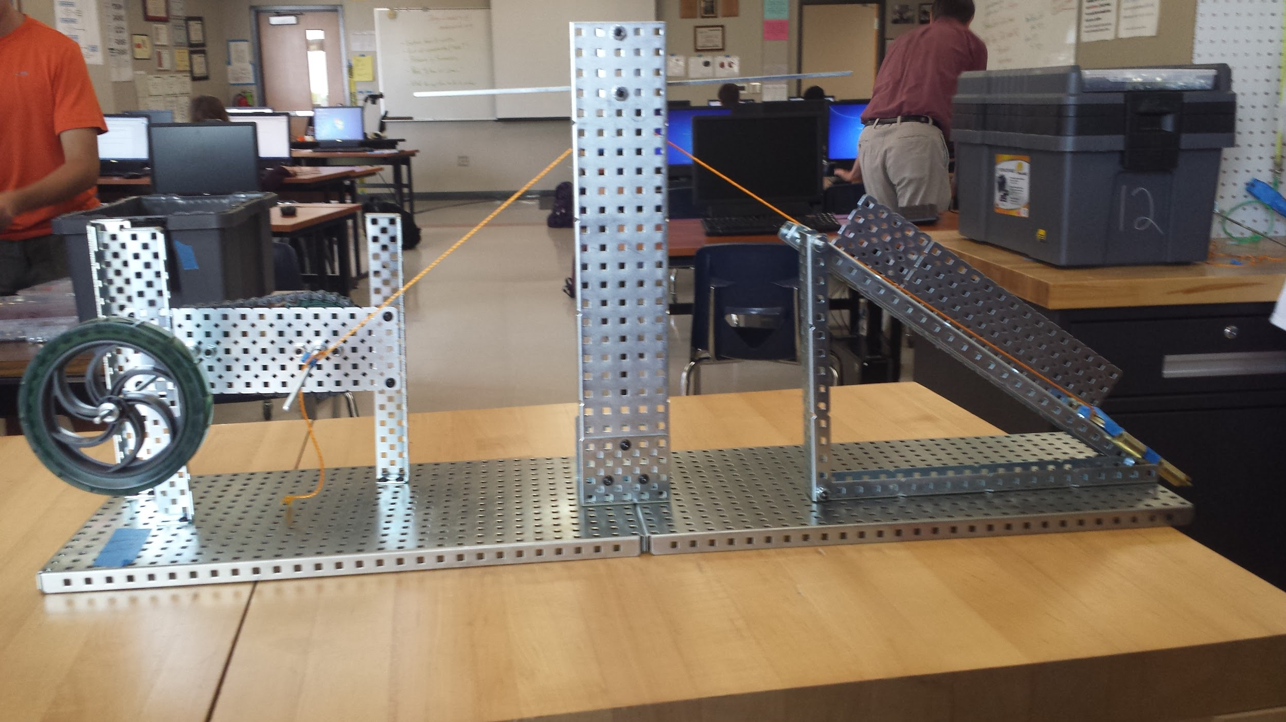
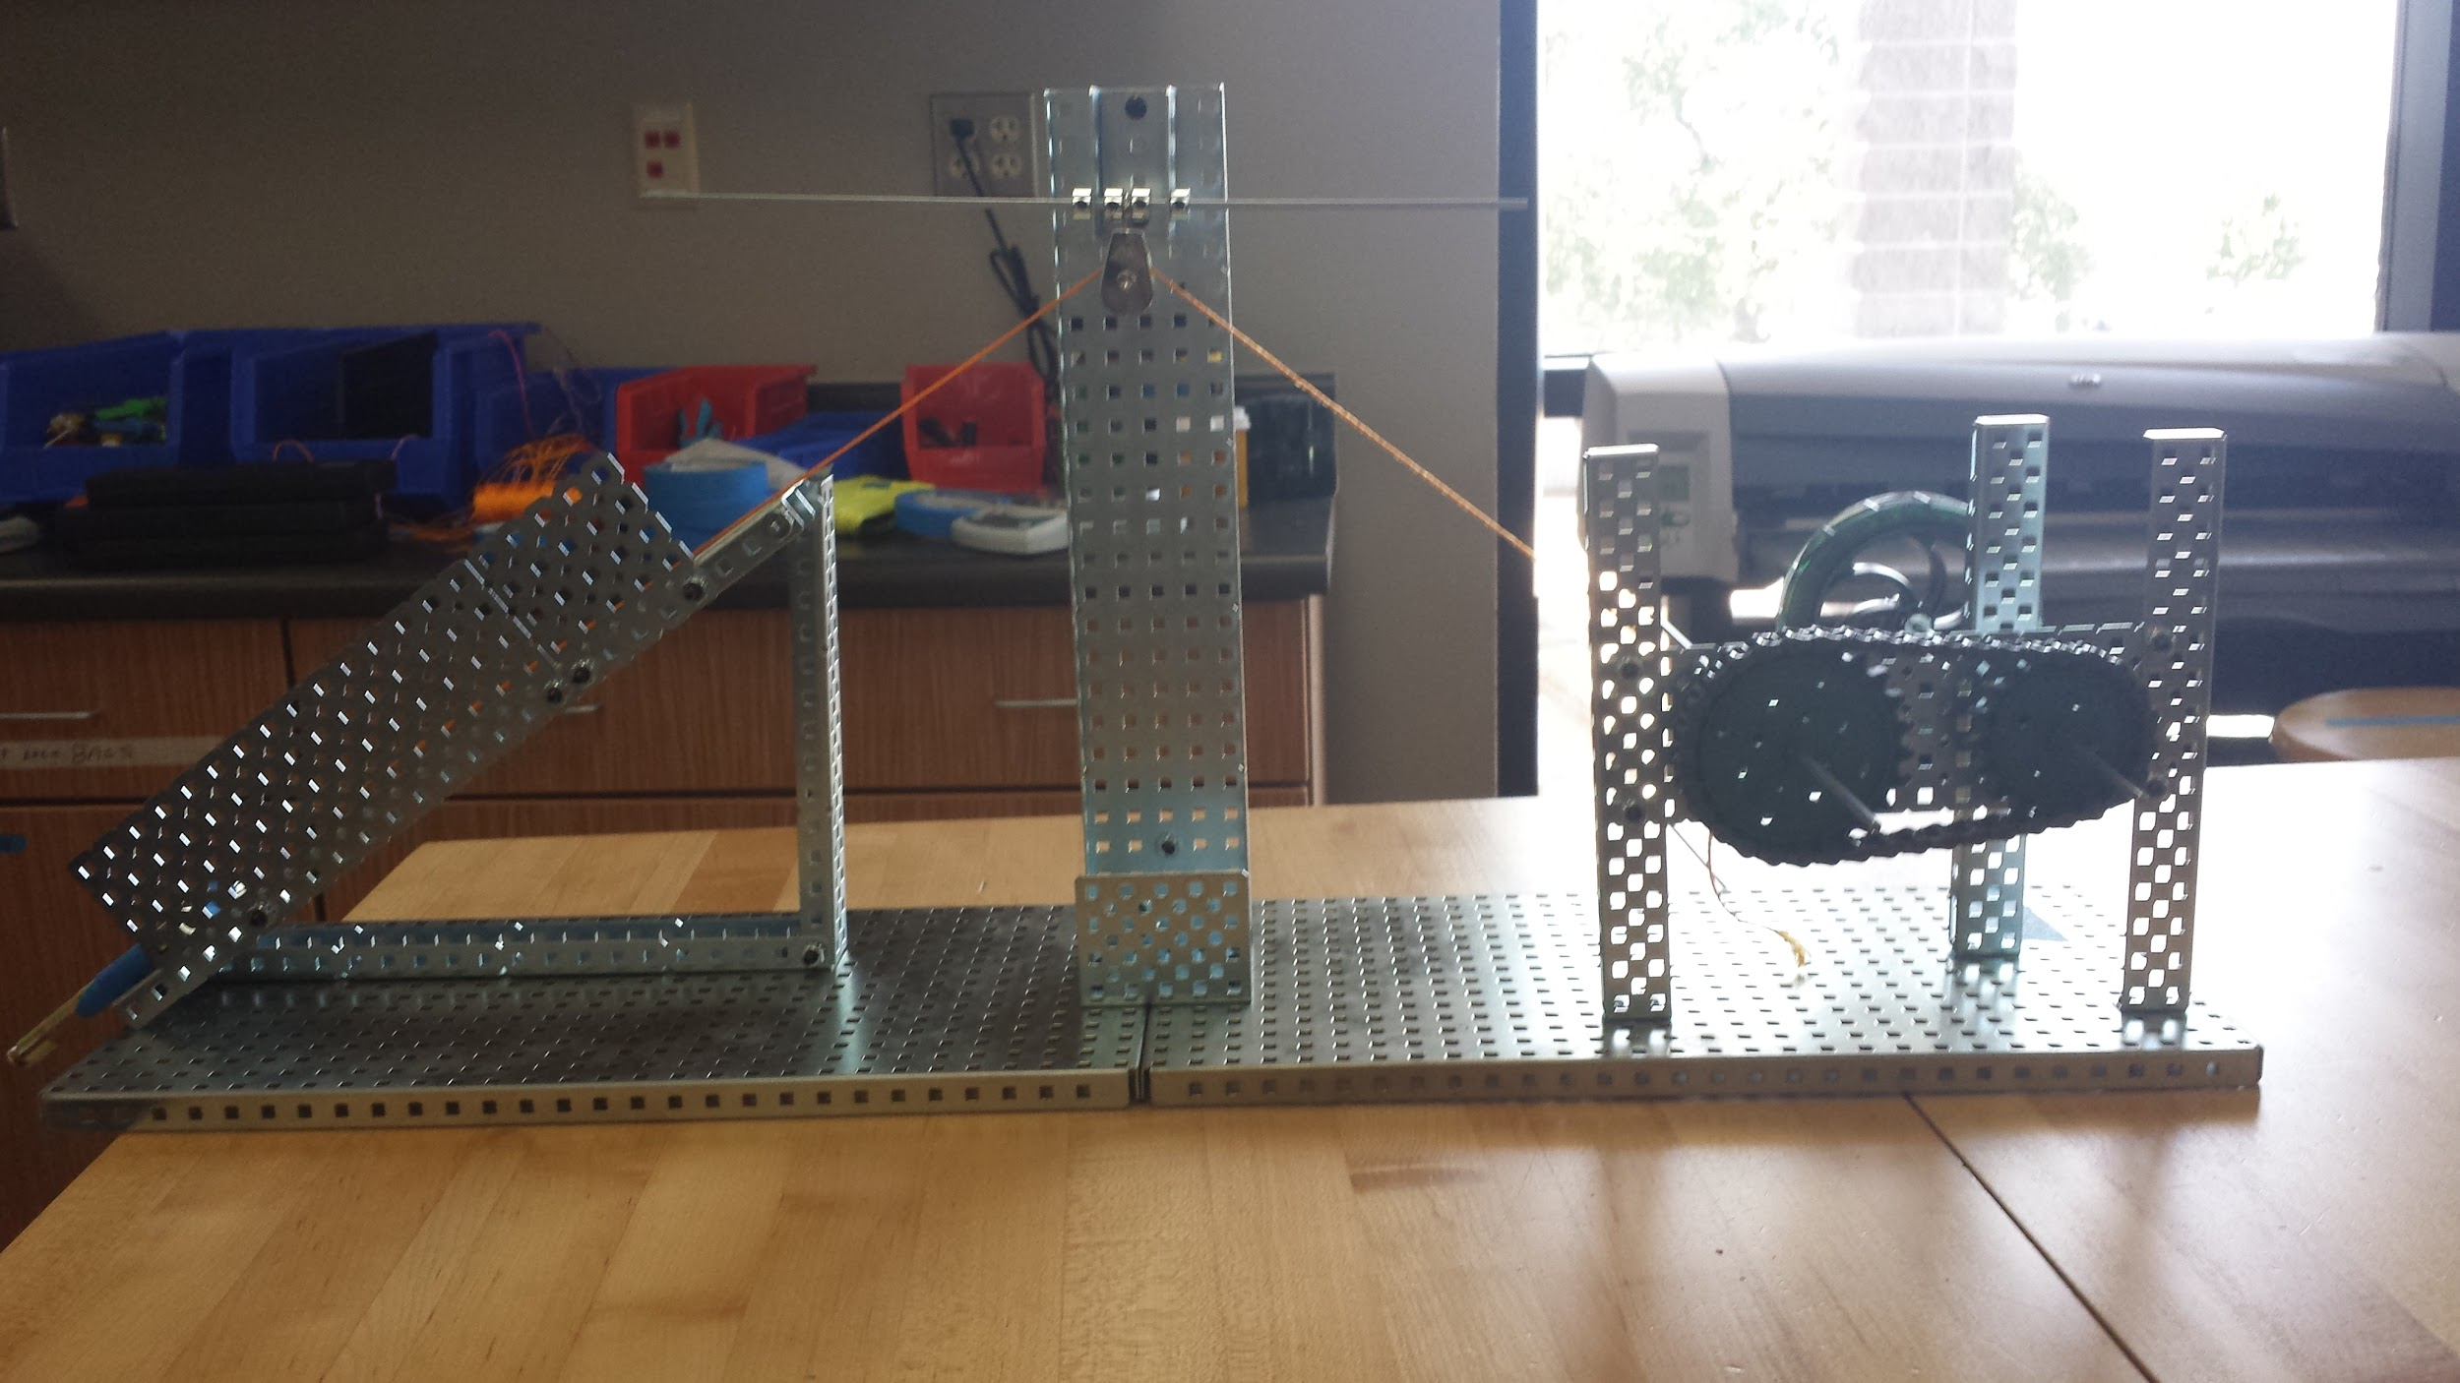

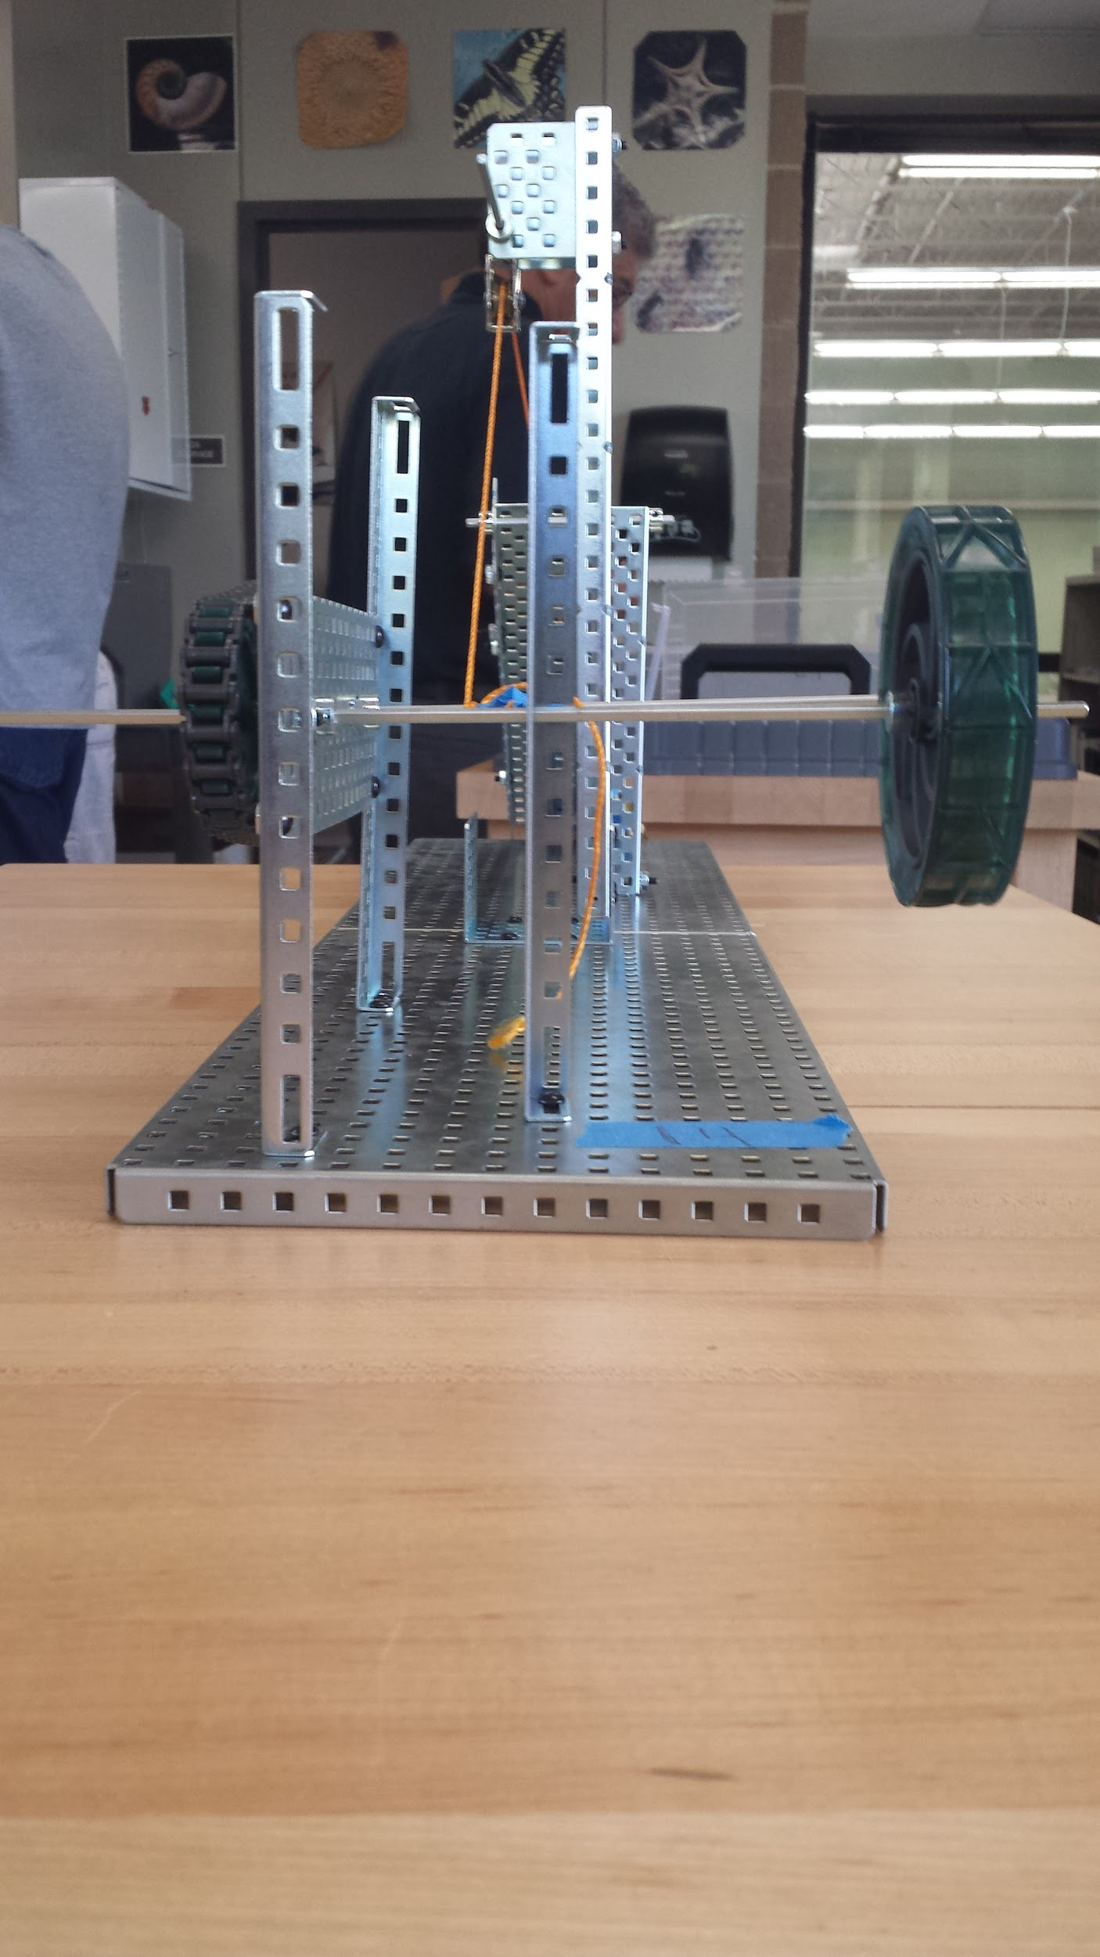

Team Evaluation

I built the sprocket system portion of our compound machine. I followed group norms, and was open to modifications to the original design.
Vivek missed a building day, and followed group norms by informing us when he was going to be absent. He made up for lost time by making the wheel and axle, and helping with the modifications. He was a great team member who was always willing to help, and contributed great ideas.
Jugal built the fixed pulley, and helped with the modifications. He is a very fast worker and efficient worker. He also followed all group norms.
John built the inclined plane, and came up with the idea to double the width and add a railing to the inclined plane. He is very good with calculations, followed group norms, and made sure everyone was keeping up with their work.

Post-Mortem Reflection

- It was easiest to determine the ideal mechanical advantage of the sprocket system. This is because there was no ruler or caliper measurement involved, which would have lead to human error in the calculations. Instead we had to count the number of teeth of each sprocket gear.
- It was most difficult to calculate the actual mechanical advantage of the entire system because measuring the effort force was very tedious. It is hard to get an accurate reading on the pull scale, while pulling the string at the same time.
- If we didn’t have to worry about time, I would have added a spool to the axle of one of the sprocket gears which would decrease the ideal mechanical advantage of one of the wheel and axles,and increase our efficiency. I also would have readjusted the inclined plane to align with the pulley, to make it easier to pull the object.
- I would have changed the fixed pulley to a block and tackle pulley system because after building the compound machine, I realized that the fixed pulley wasn’t contributing anything to the overall machine. Changing it to a block and tackle pulley system would add mechanical advantage to the compound machine.

